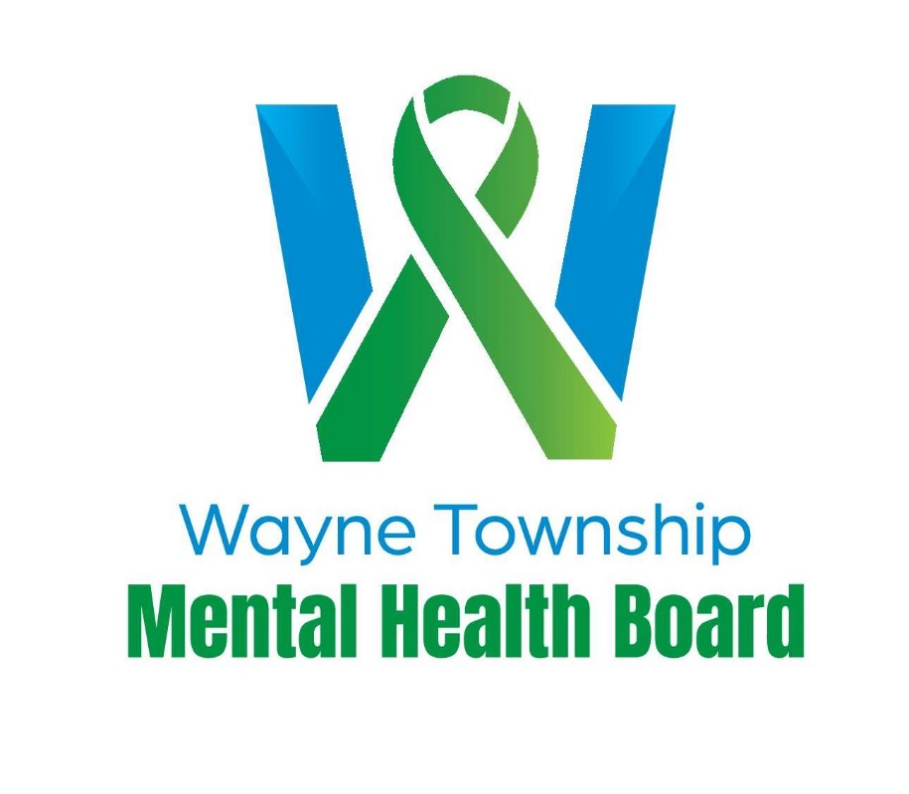

Wayne Township Mental Health Board
27W031 North Ave.
West Chicago, IL 60185

Wayne Township Mental Health Board
Funding Application for Fiscal Year Ending March 31, 2027
Wayne Township Mental Health Board Funding Guidelines
The Wayne Township Mental Health Board is pleased to accept applications for FY2027 funding.
The Wayne Township Mental Health Board ensures that services in the area of mental health, including developmental disabilities, addictions, and substance abuse, are available to all residents of Wayne Township. Other issues, as determined by the Board, may be addressed in our community.
For the 2027 funding cycle:
- The board expects to have approximately $1 million in funding available to award based on submissions. This board may also elect to provide additional funding opportunities later in the year, while holding some of the funds in reserve for that purpose.
- 100% of funds distributed must be used to serve Wayne Township residents only. Applicants may be asked to submit documentation to confirm township residency.
- Award recipients will be required to agree and sign a funding contract. Funding will be distributed periodically as determined by the Board following receipt of satisfactory documentation of services provided. Final reports will be due at the end of December 2026.
- Must be a verified not-for-profit organization 501(c)(3) or governmental agency.
- Applicants may be asked to give a formal presentation to the WTMHB before making any grant decision.
Application Process:
- Applications are available no later than January 26, 2026.
- Application deadline: February 27, 2026, at 4:30 PM. Please be available for interviews during the week of March 9th, 2026.
- Please submit a complete and signed application. They should be submitted electronically to Supervisor Randy Ramey at rramey@waynetwp-il.org. All documents MUST be sent in a PDF format.
- The WTMHB expects to review applications for funding in March 2026.
- The Board will make funding decisions and notify applicants within seven days of award decisions.
- Questions on the application process may be emailed to rramey@waynetwp-il.org.

Organizational Information:
Agency Name:

Program Name:

Amount Requested:

Address, City, State, Zip Code:

Telephone:

Executive Director: Telephone:

Email:

Name and Title of Contact Person:

Contact Telephone: Contact Email:

Primary Service category of the program for which you are seeking funding (check all that apply)
Substance Abuse

Mental Health
Developmental Disabilities

Please summarize the purpose of your request (500 words or less):

Services for which you are requesting funds:
The Mental Health Board funds programs in the areas of mental health, substance abuse, prevention and intervention, and developmental disabilities that serve residents of Wayne Township. Wayne Township has a population of over 64,000 residents encompassing 36 square miles of DuPage County, covering portions of 6 communities: Carol Stream, Bartlett, Hanover Park, St. Charles, Wayne, and West Chicago. Wayne Township boundaries are Devon Ave. to the north (the DuPage/Cook County Lines). ½ mile east of County Farm Rd, (the Wayne/Bloomingdale Township border), Hawthorne Ln. to the south, and the boundary to the west is Kautz Rd. (the DuPage/Kane County Lines). If you have questions about boundaries or would like a map sent to you, please contact Wayne Township for more information.

- If the program is currently operating, how many years has the program been in existence?

- If the Mental Health Board can only fund part of your request, how do you fund the remainder of the program?

- Does your organization engage in community education or outreach programs? If yes, what do you do?

- All clients/participants funded by this award must be Wayne Township residents. Please explain or include your residency check policy.

- Do you charge a fee for your program/service? If yes, how much?

- Is there any other relevant information you would like to add to this application?
Budgeting and Funding
- What was the total budget for your agency for the past fiscal year?

- What were the actual costs or expenses?

- What is the budget for the proposed program? Please attach the budget.

Future Documents Needed:
If approved, funding is contingent on presenting these documents:
- Previous year’s budget
- Audit of the past fiscal year
- Proposed budget for the upcoming year
- Most recent annual report
- Copy of IRS 501(c)(3)
- Current Certificate of Insurance

REMINDER: Agencies do not need to send paper copies to the Mental Health Board. All documents should be submitted electronically in a PDF format.

For Providers
By signing this application, I certify the statements contained in the list of certifications, and that the statements herein are true, complete, and accurate to the best of my knowledge. I have provided the required documentation and agree to adhere to the services as presented in the application, and I will comply with any resulting terms and conditions when the award is accepted. I am aware that any false, fictitious, or fraudulent statements of claim may subject me to criminal, civil, or administrative penalties. I understand that the funding disbursement is contingent on the availability of tax revenues collected by Wayne Township. This application has been reviewed and approved by:
Signature of Provider: ______________________________________________
Date: ___________________________________________________
Printed Name and Title of Provider: _________________________________________

