Service Provider Survey Executive Summary
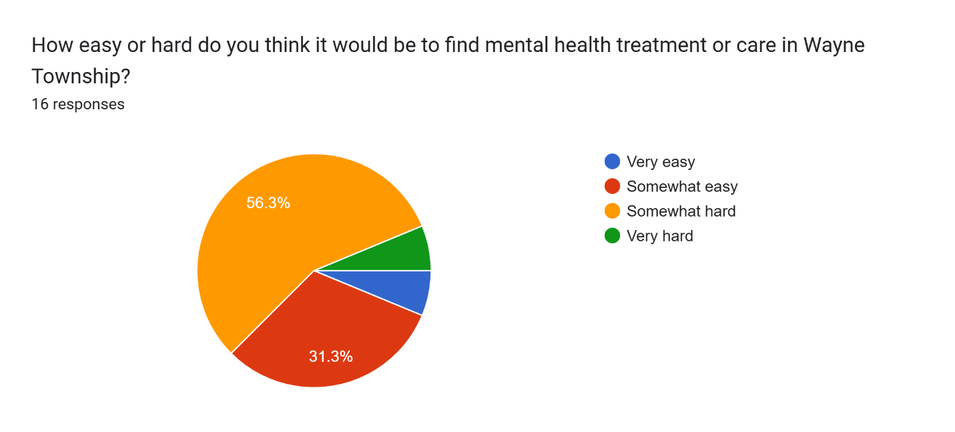
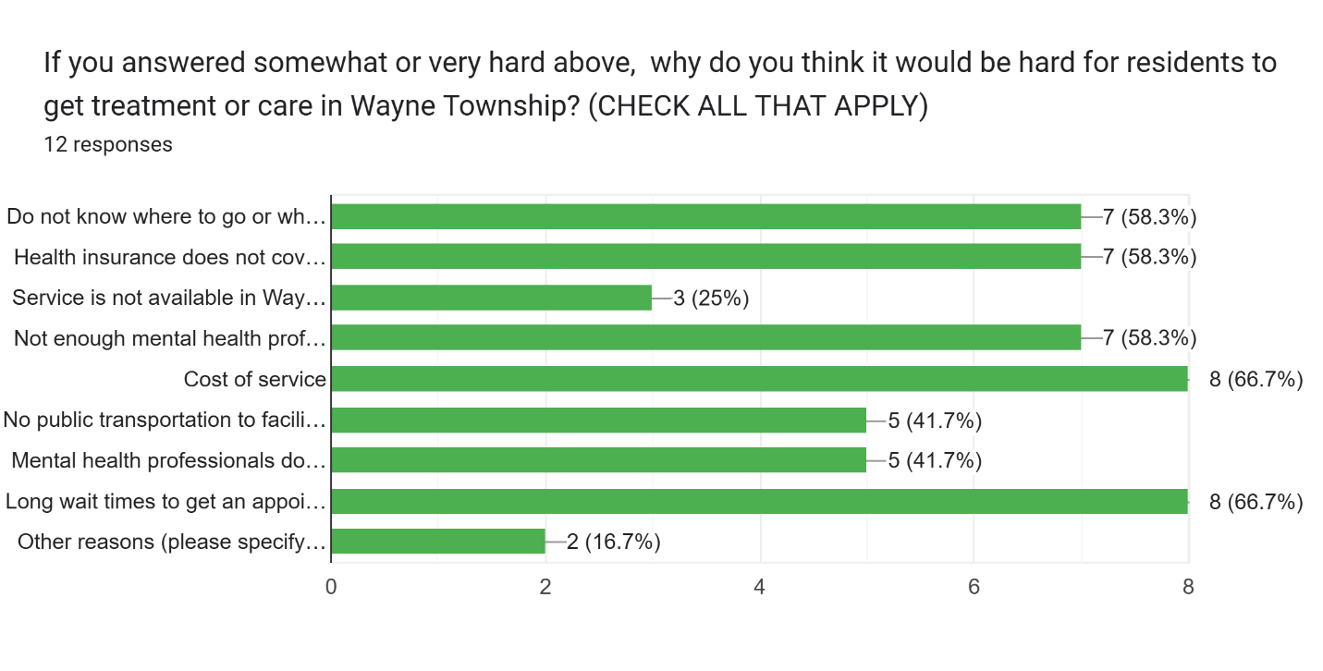
If you answered "other reasons" above, please share your reasons here:
Most well-qualified clinicians do not take Medicaid. Additionally, the cost of mental health treatment is prohibitive, even with acceptable insurance, because high co-pays or co-insurance is required at each session, sessions are 1x/weekly or greater.
Specialized mental health services for very young children and those with disabilities

What type of mental health support service is not available in Wayne Township?
free mindfulness help
psychiatry, testing, Spanish speaking therapists, support groups
Psychiatry, low cost counseling, help purchasing insurance, medication assistance, services in languages other than English
Group and family therapy seemingly inadequate... especially when language, cultural barriers are in play
Affordable substance abuse treatment
Assessment psychologists and prescribing psychiatrists who take Medicaid

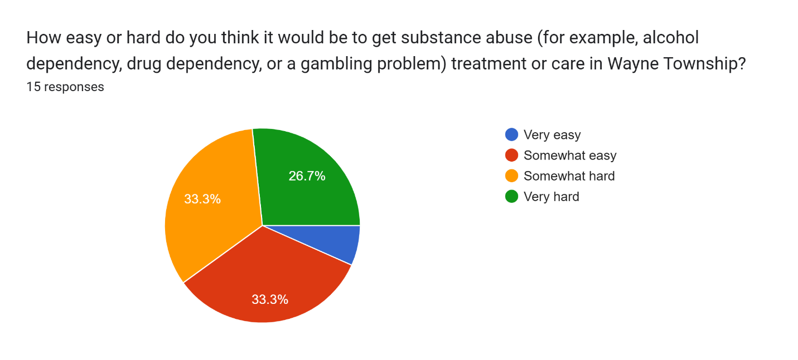

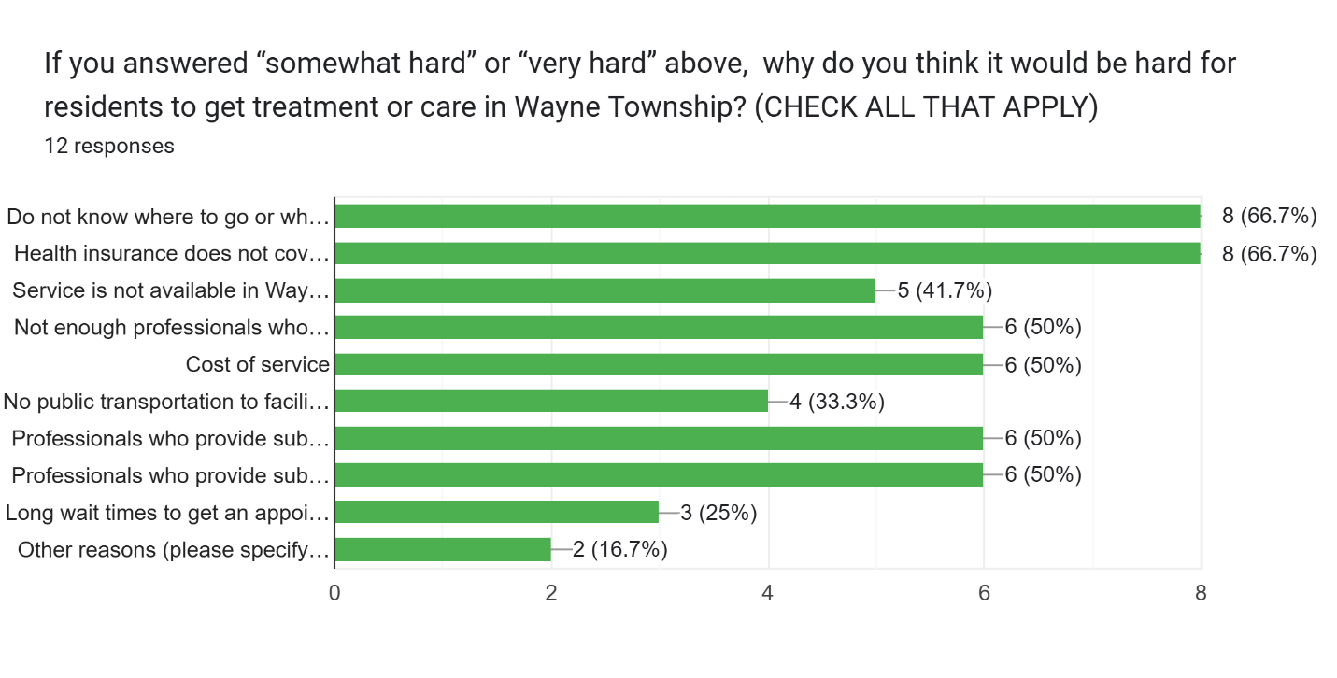
If you answered "other reasons" above, please share your reasons here:
Most residential treatment centers are full and many take limited, selected, forms of insurance.

What type of substance abuse support service is not available in Wayne Township?
Intensive Outpatient and Partial Hospitalization
Services for Medicaid, Medication Assisted treatment, Medication assistance, Psychiatry, support groups besides AA
Detox ... short and long term rehab programs. Access to adequate groups and support networks.

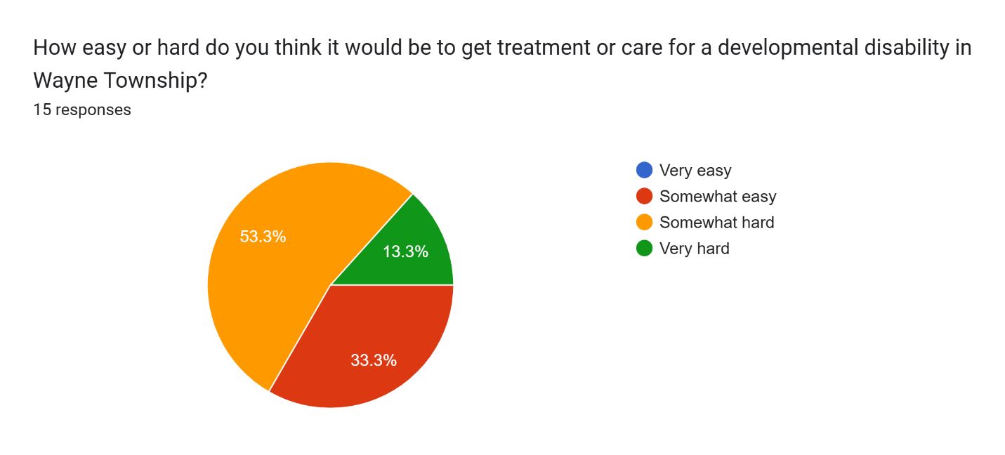
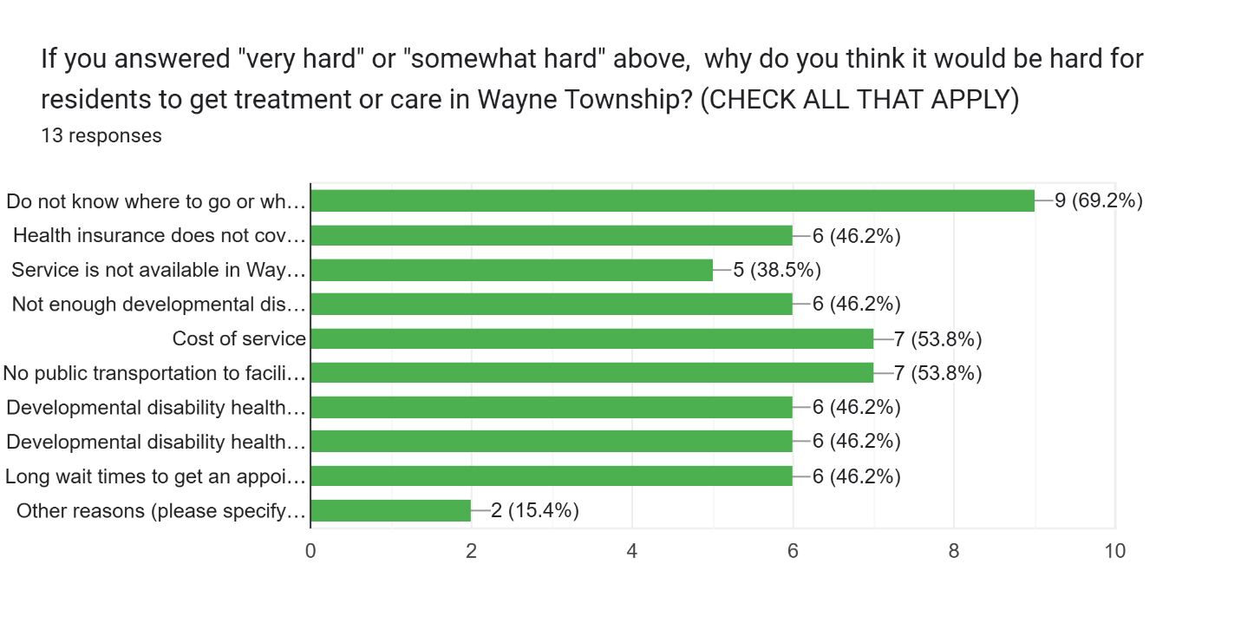
What type of support service for people with developmental disabilities is not available in Wayne Township?
I am not aware of direct service providers accepting Medicaid serving within WT
Short and long term housing. Support services to provide basic help to help gain appropriate independence. Job coaching and shortage of jobs. Inadequate IL state services for people with disabilities. Inadequate collaboration.
Day programming/Recreational Programming
Psychological assessment
Overall, what are the biggest issues or needs related to mental health, substance abuse, and developmental disabilities in Wayne Township?
Access/Not enough providers/long wait times (especially for underserved populations) - 6
Stigma/cultural acceptance - 3
accepting all forms of insurance (Medicaid or sliding scale fee) providers – 4
Communication about availability - 4
language barriers - 3
Affordability
Transportation
people without insurance don't get the help that they need
Insurance denials, care limits and low reimbursement rates.
low cost and culturally accessible services including medication and medication assisted treatment, counseling, case management, psychiatric services, and support for dual diagnosis and co-occurring disorders, Needs cover the life span.
flexible hours of availability
Affordable outpatient mental health and substance abuse treatment (Eng/Spanish)

What are the strengths and weaknesses of the local systems that provide mental health, substance abuse and/or developmental disability services?
access of care
The organizations that are available are small and don't have a large capacity
these services can be expensive and if have no insurance, it will be hard to get them.
I think that people are afraid of being vulnerable and ask for help and there is a lot of fear as culturally they are not used to ask for help.
Strengths - wide network county-wide of service providers. Challenge: access in all its forms
Collaboration between various service providers is a strength. funding is the biggest challenge agencies face which limits access for those who need it most.
In DuPage County (not necessarily Wayne) there are high quality medical providers, health systems, counseling agencies (for profit and nonprofit both) etc. But there is inadequate availability of low cost treatment options for uninsured or Medicaid enrolled, psychiatric services are woefully inadequate, and wait lists for care for low income are often long. There is also a need for more culturally and linguistically appropriate services. LARC (Language Access Resource Center) is a valuable resource, but counseling with interpretation really isn’t best practice.
Those who are here really care and understand this community. They are willing to help and often go above and beyond
Lack of publicity
We have a wonderful county behavioral health crisis system. The 211 system is an excellent source of information for people. Weaknesses: Again, lack of nearby substance abuse treatment (IOP and PHP), lack of Spanish-speaking providers, transportation barriers
Too much overlap county/township
Good peer support services like NAMI and AA and many providers for those with private insurance but not enough Medicaid providers

Related to mental health, substance use and disabilities, what could be done to improve the quality of life in the community?
Help with co-pay or co-insurance expenses with some form of fee offset.
Access to care on website list of providers
Increase service capacity though increased funding
I think that depression support groups in Spanish could help people to get help.
Coordinate services and make them available via awareness and coordination. Too many grant dollars wasted - when we are duplicating services and not coordinating efforts that make services available to those who can most benefit from them!
Increase awareness and reducing stigma by promoting and partnering with existing service providers.
Subsidies for providers delivering services at a loss (gap funding), medication assistance, help purchasing high quality health insurance, funding for psychiatric care.
The fee structure of care and the availability based on insurance has to change
More awareness to the needs and to the assets available in the community. Better collaboration.
A system where people can ask questions on where to get services
Increase the number of bilingual providers (MH & SUD treatment). Create a fund to provide rides for people to get to and from their appointments at DuPage County Behavioral Health and other providers.
Better support services
From a school perspective how to partner with the school and outside agencies

What co-occurring issues do you see with your mental health, substance abuse and/or developmental disability clients?
Affordability
Domestic violence
financial issues/stress - IIII
depression and anxiety - II
Adequate Housing - II
employment that pays a living wage - III
parenting stress, unhealthy co-parent relationships,
transportation
long wait lists for services
Funding does not cover cost of services.
trauma, drivers of health, poverty, stigma/reluctance to seek treatment
Lots of family care needed--not just an individual within the family. A whole family approach is crucial, with providers being willing to communicate amongst each other to support
Relapse, despair, inconsistency, dependence on things that don't help, increased availability to harmful substance, lack of desire to improve, limited hope, limited opportunity for lasting rehabilitation...

What is the name of your organization?
Center for Cognitive-Behavioral and Prescriptive Psychotherapy, Ltd.
Goodman Psychologist Associates
Wayne Winfield Area Youth Family Services (WAYS)
Resurrection Church
Healthy West Chicago
Teen Parent Connection
Easterseals DuPage & Fox Valley
DuPage Health Coalition
West Chicago Community HS
Christ Fellowship Church (formerly Community Fellowship)
BZA Behavioral health
Carol Stream Police Department Social Services Unit
Center for Personal Growth, PLLC
Wheaton Academy

What services do you provide?
I am a licensed clinical psychologist providing individualized treatment for depression/mood-spectrum disorders, anxiety-spectrum disorders/PTSD, substance abuse disorders. I am experienced in the treatment of those with co-morbidity and complex problems.
Individual therapy for children through adults, couples, families and psychological testing
Mental health counseling, group counseling, youth tutoring, youth summer day camp, in-school prevention groups
faith based
Cooking classes, nutrition workshops, movement events
Now celebrating 40 years of service, Teen Parent Connection is a nonprofit organization supporting adolescent parents in DuPage County, Illinois. Through a comprehensive continuum of care, the agency helps young families build healthy foundations from pregnancy through early childhood. Core services include home visiting, doula support, childbirth education, and weekly parenting groups. Young fathers receive tailored support to strengthen their parenting role and co-parenting relationships. The agency also provides comprehensive mental health services, including individual, couple, and family counseling. Therapy is offered in-office or in-home and is grounded in trauma-informed, culturally responsive care. These services help young parents manage stress, strengthen relationships, process past experiences, and build resilience for themselves and their children. The Parents’ Pantry - provides essential items—like diapers, formula, clothing, and hygiene supplies—through an incentive-based system. Participants earn “baby bucks” by setting and achieving personal and parenting goals, reinforcing positive engagement. Teen Parent Connection also leads prevention and education efforts in local schools and the community. These programs are fact-based - medically accurate and meet Illinois state guidelines for comprehensive reproductive health education**, with content focused on healthy relationships, decision-making, and pregnancy and STI prevention. Peer educators share personal experiences to connect with students and encourage informed choices. All services are free of charge and designed to help young families thrive.
Pediatric therapy, including mental health and Early Intervention for children with disabilities. Also provide audiology services for all ages and all abilities.
Comprehensive health access for low income and uninsured residents, subsidy for health insurance purchase, health education including mental health first aid and Take Charge of Your Diabetes, free pharmacy in Wheaton
Public Education
Support and care for those with connection to our church community... at this time limited support for others in the broader community.
Therapy, medication management, and neuropsych testing
We provide crisis intervention, free counseling to residents of CS & crime victims, community programming, court advocacy for victims, Christmas Sharing program, Summer back-to-school backpack giveaways (4 complexes in town)
Mental health assessment and outpatient treatment, and assessment for developmental disabilities

What geographic area do you serve?
I am in unincorporated West Chicago and I have patients coming from as far as Park Ridge.
Wayne and surrounding areas including bartlett
Towns in Wayne & Winfield Townships
wayne township
West Chicago
DuPage County and Schaumburg Township
All of Suburban Chicago with centers in Elgin, Naperville and Villa Park
DuPage County
West Chicago, Winfield, Carol Stream
Greater Chicagoland
The Village of Carol Stream
Carol Stream

