Community Survey Executive Summary
MENTAL HEALTH
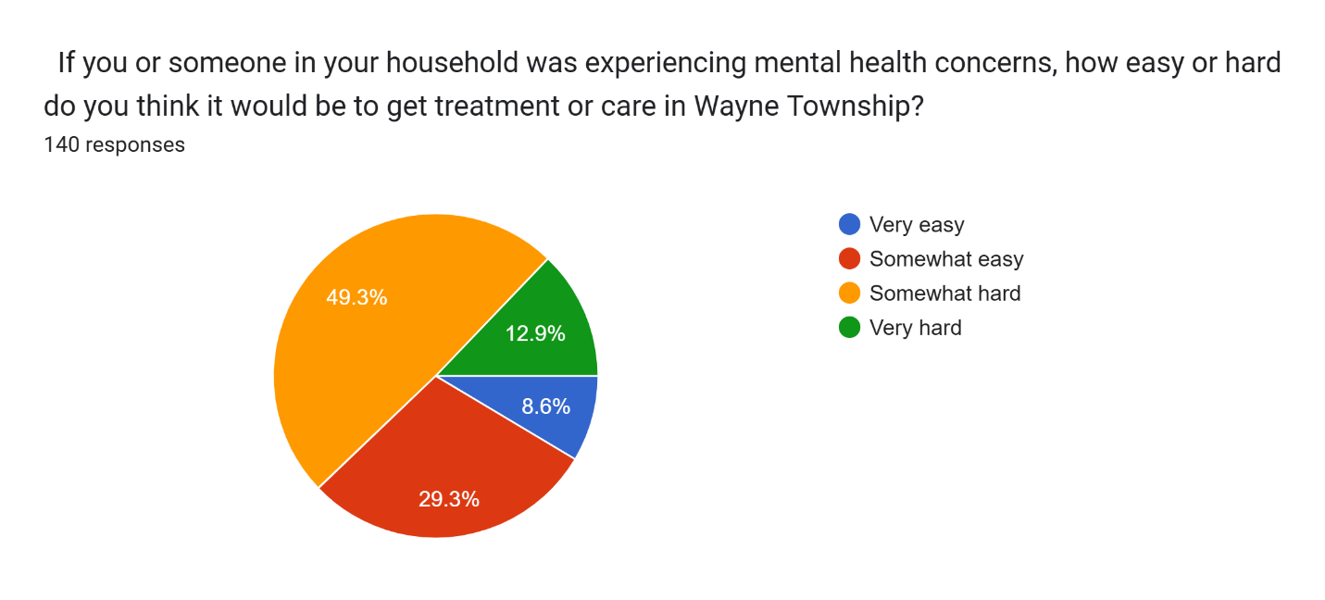
If you answered somewhat or very hard above, why do you think it would be hard to get treatment or care in Wayne Township?
Do not know where to go or who to see – 82%
Cost of service – 42%
Long wait times to get an appointment – 40%
Not enough mental health professionals in Wayne Township – 34%
Service is not available in Wayne Township – 24%
Health insurance does not cover – 17%
No public transportation to facilities – 16%
Mental health professionals don’t take Medicaid – 16%
Other:
- Very difficult to find good information. Lack of community education
- No services available when we needed
- Some comments that the Township shouldn’t be involved in mental health issues.

What type of mental health support service is not available in Wayne Township?
Most responders were not sure.
Responses given:
LGBTQ+ aware professionals
Support groups
Need more substance abuse treatment
No hospitals or medical centers
Drug abuse, depression
Providers who see kids under 10
Pediatric psychiatry
Providers that take Medicare & Medicaid
Early intervention programs at schools
Transportation options for disabled people
speech therapy, dyslexia, elderly care, caregiver support,
Hospitalization for behavioral health/meds
For kids and teens in the foster care system experiencing the effects of trauma.
Different kind of mental health help is needed that includes the whole family since the mentally ill person may not be able to make decisions for themselves
Specialist in neurodivergent care
Young adult/teen support
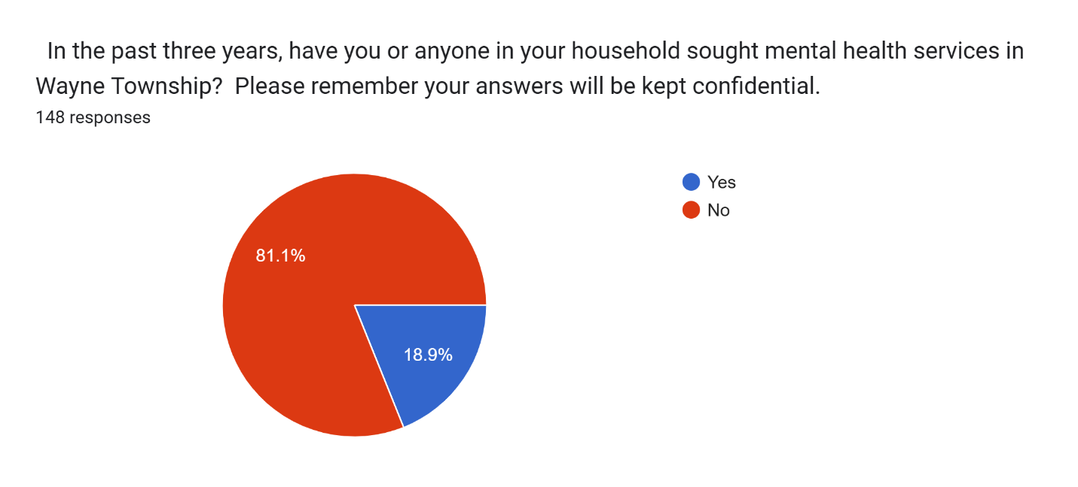

SUBSTANCE USE
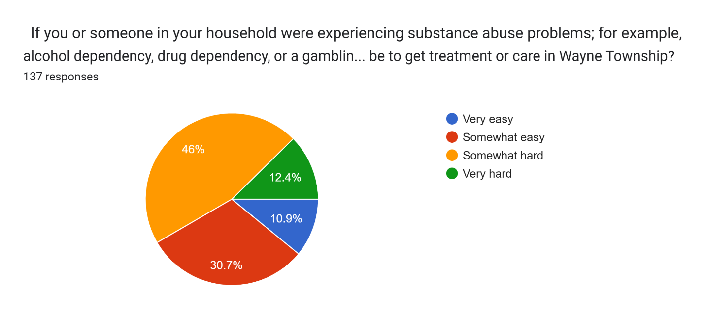If you answered “somewhat hard” or “very hard” above, why do you think it would be hard to get treatment or care in Wayne Township?
Do not know where to go or who to see – 57%
Not enough professionals who provide care in Wayne – 16%
Cost of service – 16%
Long wait times to get appointment – 15%
Health insurance doesn’t cover it – 8%
Service not available in Wayne – 9%
Professionals who provide support don’t take Medicaid – 7%
No public transportation to facilities – 5%
Professionals who provide support don’t speak my language – 1%
Other reasons
- Too few success stories
- Some comments that the Township shouldn’t be involved in substance use issues.
*Please note that several people took the survey before the option to select multiple option was fixed and so some were only able to select their top choice.

What type of substance abuse support service is not available in Wayne Township?
Most replies were unsure.
Other responses:
Residential programs
Inpatient facilities
Drug awareness presentations
Support groups
Addiction support
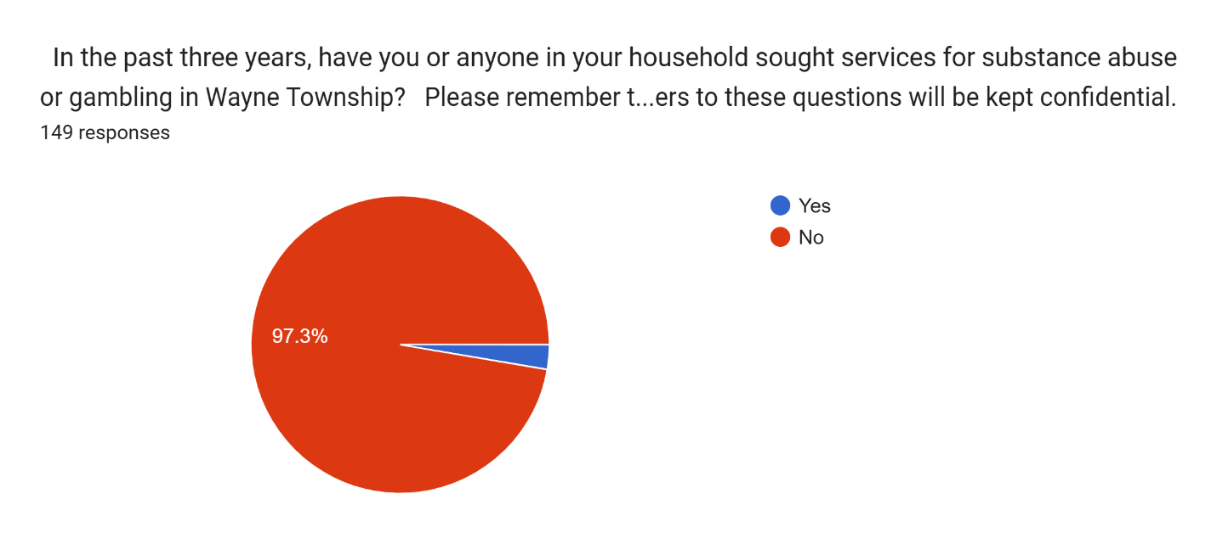

DEVELOPMENTAL DISABILITIES
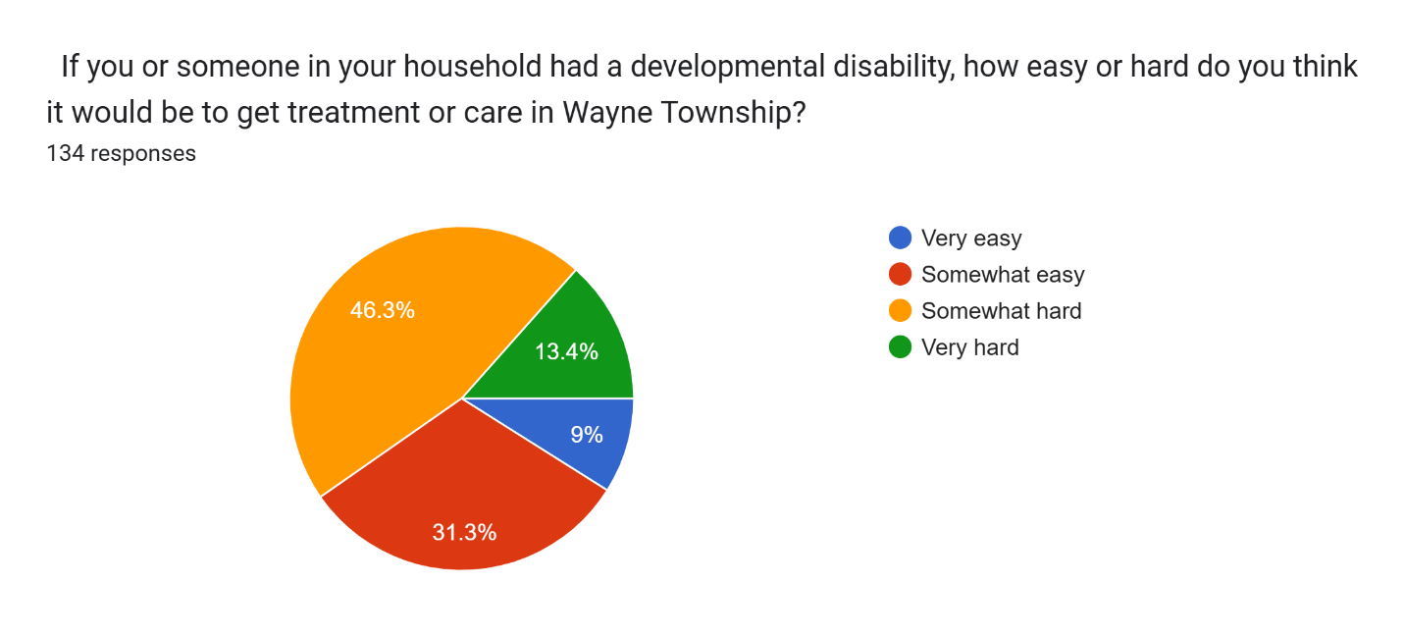

If you answered "very hard" or "somewhat hard" above, why do you think it would be hard to get treatment or care in Wayne Township?
Do not know where to go or who to see – 59%
Not enough professionals who provide care in Wayne – 21%
Cost of service – 22%
Long wait times to get appointment – 11%
Health insurance doesn’t cover it – 11%
Service not available in Wayne – 7%
No public transportation to facilities – 7%
Professionals who provide support don’t take Medicaid – 6%
Professionals who provide support don’t speak my language – 0%
Other
- Wouldn’t know where to go or call if I needed this service. No roadmap telling me what to do.
- Too confusing and stressful
- Illinois badly underfunded for developmental disability assistance
- No one at township could direct for support
- Not enough providers and lack of support for individuals with physically aggressive behaviors. Wait lists are long and it’s a very politically driven process rather than focusing on creatively supporting the individual with a DD. This has more to do with IDHS than it does with the township, but if the township was able to enhance these services it would be life changing for individuals and their families.
- Wait times for services outside of school hours were a huge issue. Wait lists were excessive, like a year long. That is too long for a child to wait when they need developmental services, like speech or OT beyond what school can provide.
- School didn’t provide

What type of support service for people with developmental disabilities is not available in Wayne Township?
Most answered they didn’t know, however many had ideas:
- 24 hour transportation for people with disabilities.
- Assistance learning daily living skills, being able to make own decisions.
- Fatal injury and emotional trauma. Paralysis.
- More services for children on autism spectrum.
- Pediatric day school that accepts Medicaid
- Respite care for youth/teens
- Support groups for parents of kids with developmental disabilities
- Support for deaf and hard of hearing adults
- Elderly care/caregiver support. Classes to get caregivers certified for state funding
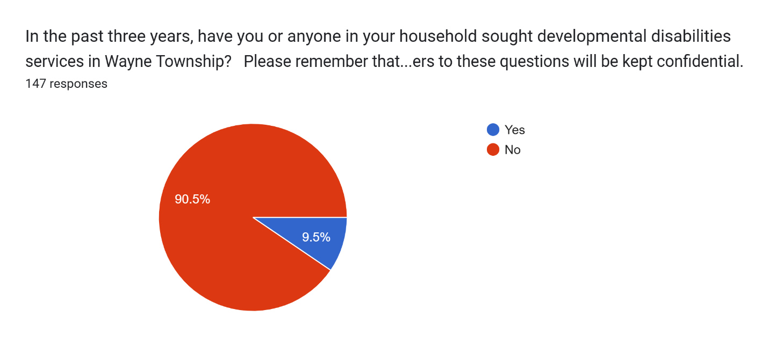
Overall, what are the biggest issues or needs related to mental health, substance abuse, and developmental disabilities in Wayne Township?
More information provided to citizens on where and how to find care (22)
Cost – (9)
Not enough professionals to meet the needs/Long wait lists (9)
Access to care (2)
Local support groups (2)
Mental health for young children (4)
Stigma (4)
Depression/Anxiety (4)
Develop a community “Wellness Hub” offering drop-in counseling, group therapy, and stress management programs. (2)
Transportation (2)
Services for adults with DD after age 22 (when schools no longer provide services)
Alcohol abuse
Help navigating technology to find providers
Services for autistic kids and families
Coordinator for financial services and eligibility
Centralized way to find providers in Wayne Township
Prevention and Early Intervention
Partner with schools for mental health screenings, counseling and resilience training
Provide teacher and staff training to identify early signs of depression, anxiety, or violent ideation.
Offer parent workshops to help recognize and address mental health or substance abuse concerns early.
Launch peer mentor programs in high schools and colleges to support students at risk.
Loneliness for seniors
No housing/treatment centers in the area
Substance use – legal and illegal
Speech and Occupational therapy
Online gambling
Online porn
Holistic care
Lack of support from employers
Inpatient hospitalizations are not long enough
Proactive mental health resources (not just when a problem arises)
Substance use education for young people
Crisis Prevention and Response
Establish a crisis intervention team combining mental health professionals with police and EMS.
Set up an anonymous tip and text line for community members to report concerns safely.
Create a short-term crisis stabilization center as an alternative to hospital ER visits.
Accessible Support & Safe Spaces
Partner with local employers to provide workplace stress programs, burnout prevention workshops, and on-site counseling. Offer accessible stress management activities such as yoga, meditation, and mindfulness sessions at little or no cost.
Lack of law enforcement for drug sales and abuse.
Stress and overworked in order to survive with our cost of living

Related to mental health, substance use and disabilities, what could be done to improve the quality of life in the community?
Increase awareness of services and how to access (26)
Increase the number of providers (6)
More affordable/providers that take Medicaid/Medicare (9)
Reduce stigma through education (5)
Support groups/family therapy (5)
Mental health reps at local events (2)
Transportation (3)
Day program for adults with DD (2)
Residential programs for substance abuse rehab (3)
Exercise/recreational activities for improved mental health (2)
Access to care (2)
Stricter law enforcement (2)
Senior services
Dietician to give guidance
Drop in center for referral
Seminars for loved ones
Help poor or marginalized communities
No more vape shops or cannabis stores
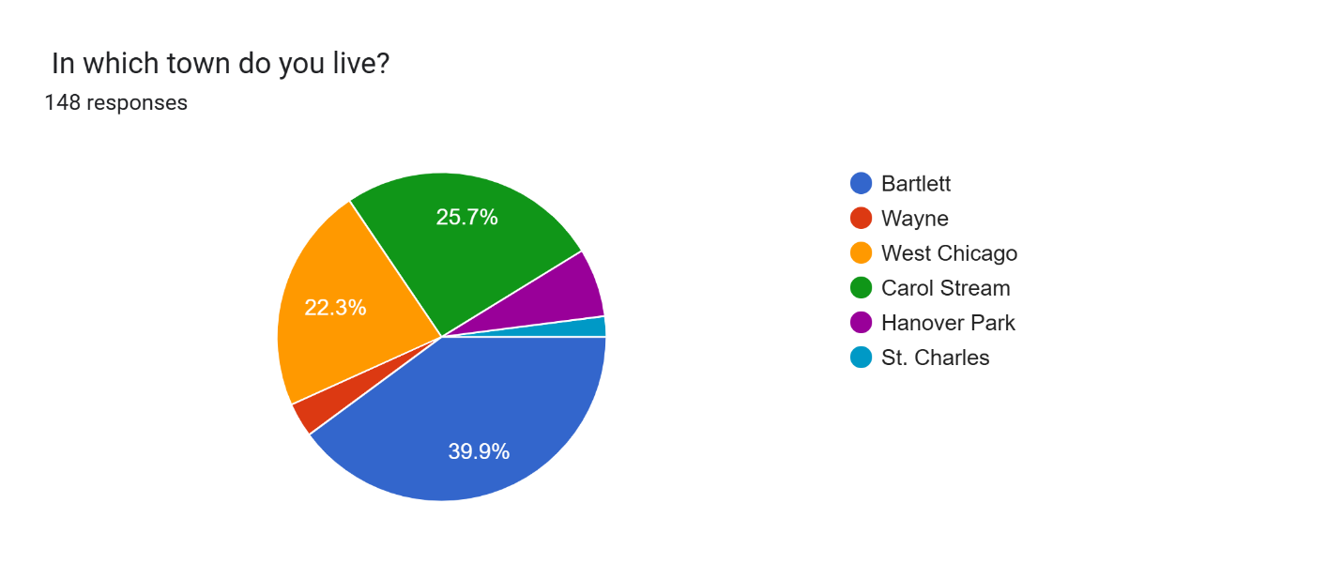
Including yourself, how many adults 18 years old and older live in your household?
2 – 54%
3 – 15%
- 13%
4 – 8%

How many children ages 17 and younger live in your household?
0 – 75%
- 11%
- 4%

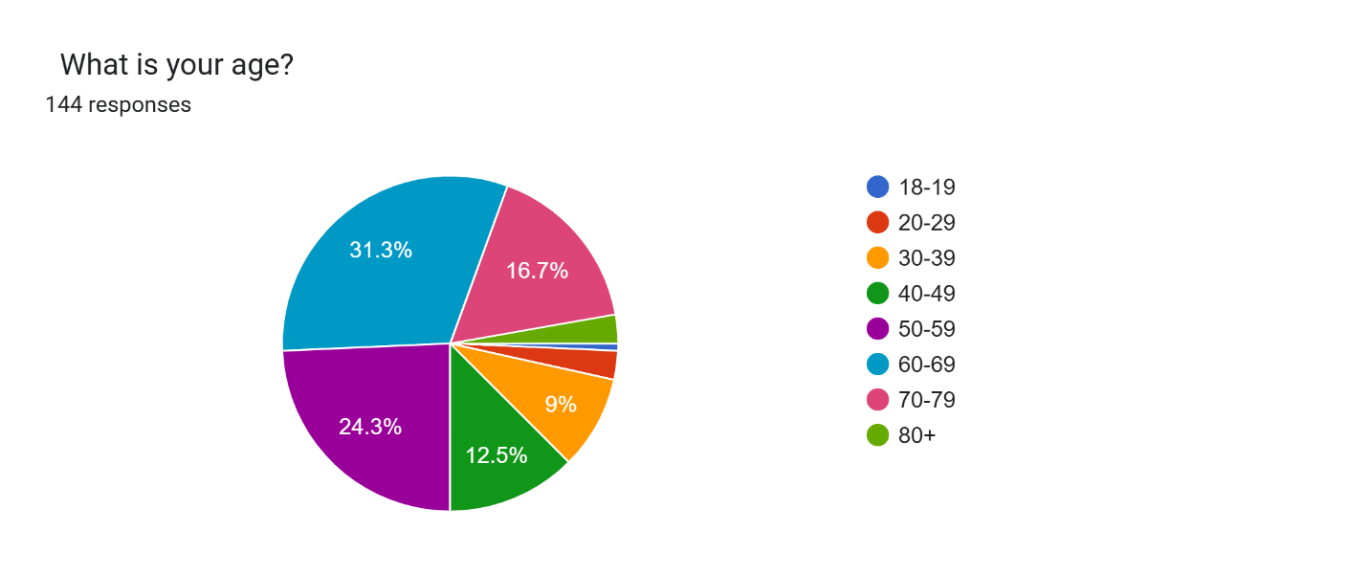
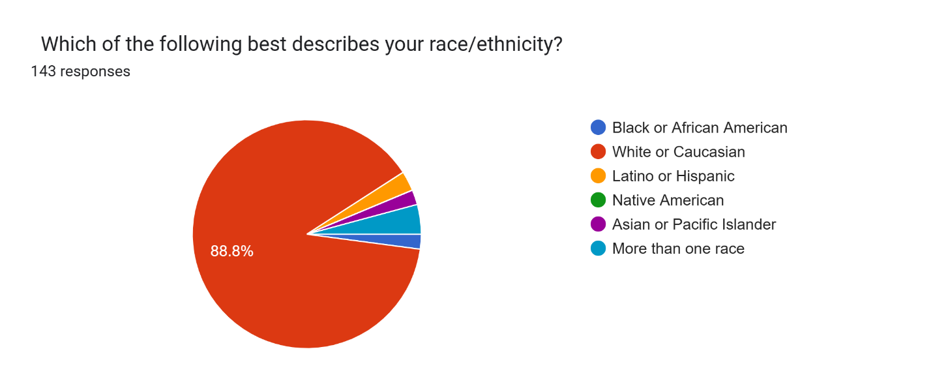
Is a language other than English primarily spoken in your home?
Yes – two Spanish, one Gujarati and one Tagalong
